**Movie Success Prediction and Sentiment Study**

09.05.25 (SAISRUTHI)  
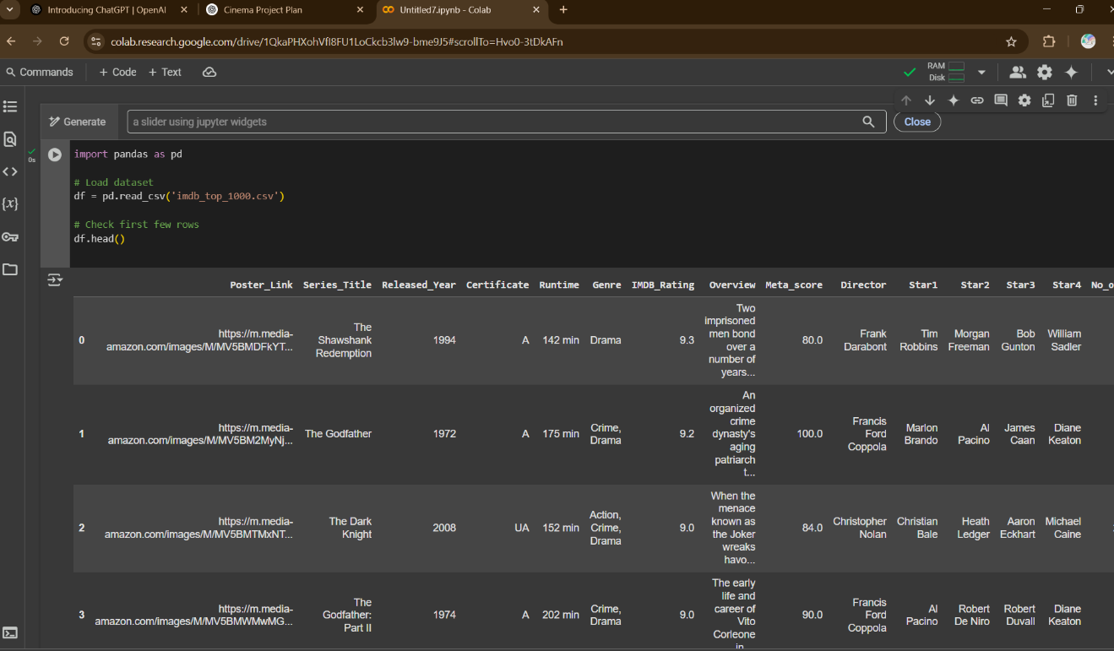

**Objective:**

The goal of this project is to predict how successful a movie will be at the box office using available metadata such as budget, genre, and viewer ratings. In future stages, I also plan to include audience sentiment analysis using viewer reviews to enhance prediction accuracy and provide deeper insights.

**Progress Completed (Till Date):**

**Environment Setup**

* Created and organized the project in Google Colab for easy access and cloud execution.
* Successfully imported essential Python libraries

**Dataset Handling**

* Downloaded and uploaded the IMDB TOP 100 Movies Dataset from Kaggle.

**Initial Data Exploration**

* Verified the shape of the dataset and checked for any missing or null values in important fields.

